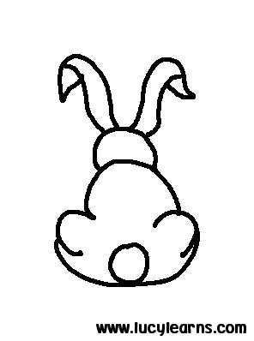
对歌 duìgē

  - 什么动物有短短的尾巴?
shénme dòngwù yǒu duǎnduǎnde wěiba？
  - 白白的兔子有短短的尾巴。
báibáide tùzi yǒu duǎnduǎn de wěiba.

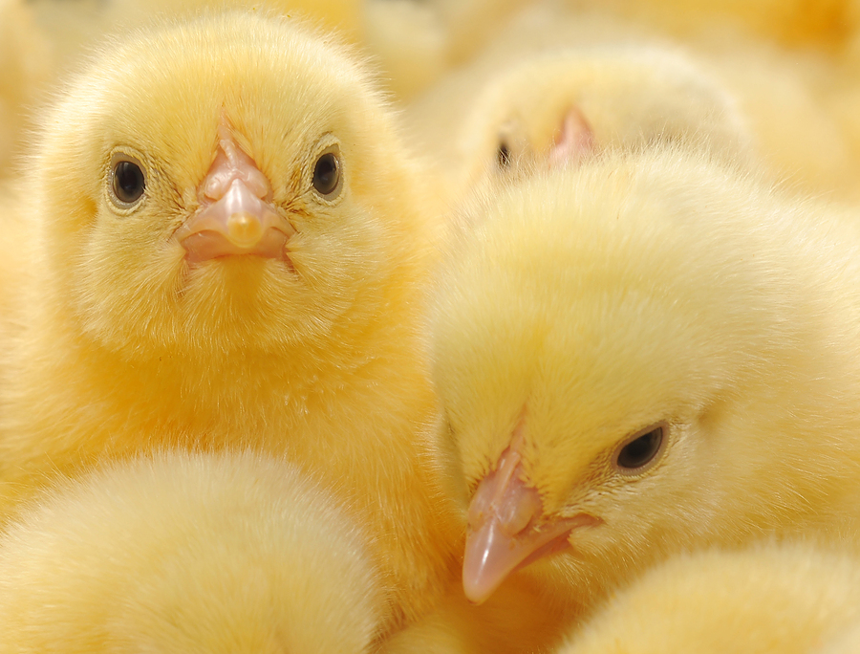
  - 什么动物有尖尖的嘴巴?
shénme dòngwù yǒu jiānjiān de zuǐba?
  - 黄黄的小鸡有尖尖的嘴巴。
huánghuángde xiǎojī yǒu jiānjiān de zuǐba.
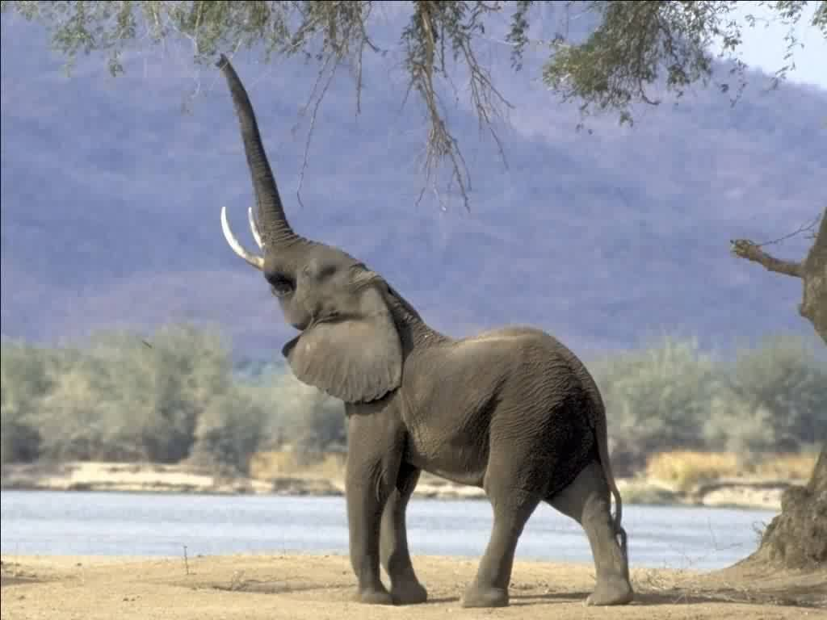
- 什么动物有长长的鼻子?
shénme dòngwù yǒu chángchángde bízi?
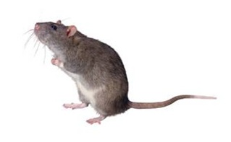
- 胖胖的大象有长长的鼻子
pàngpàngde dàxiàng yǒu chángchángde bízi
- 什么动物有小小的眼睛?
shénme dòngwù yǒu xiǎoxiǎode yǎnjīng?
- 灰灰的老鼠有小小的眼睛。
huīhuī de lǎoshǔ yǒu xiǎoxiǎode yǎn jīng.

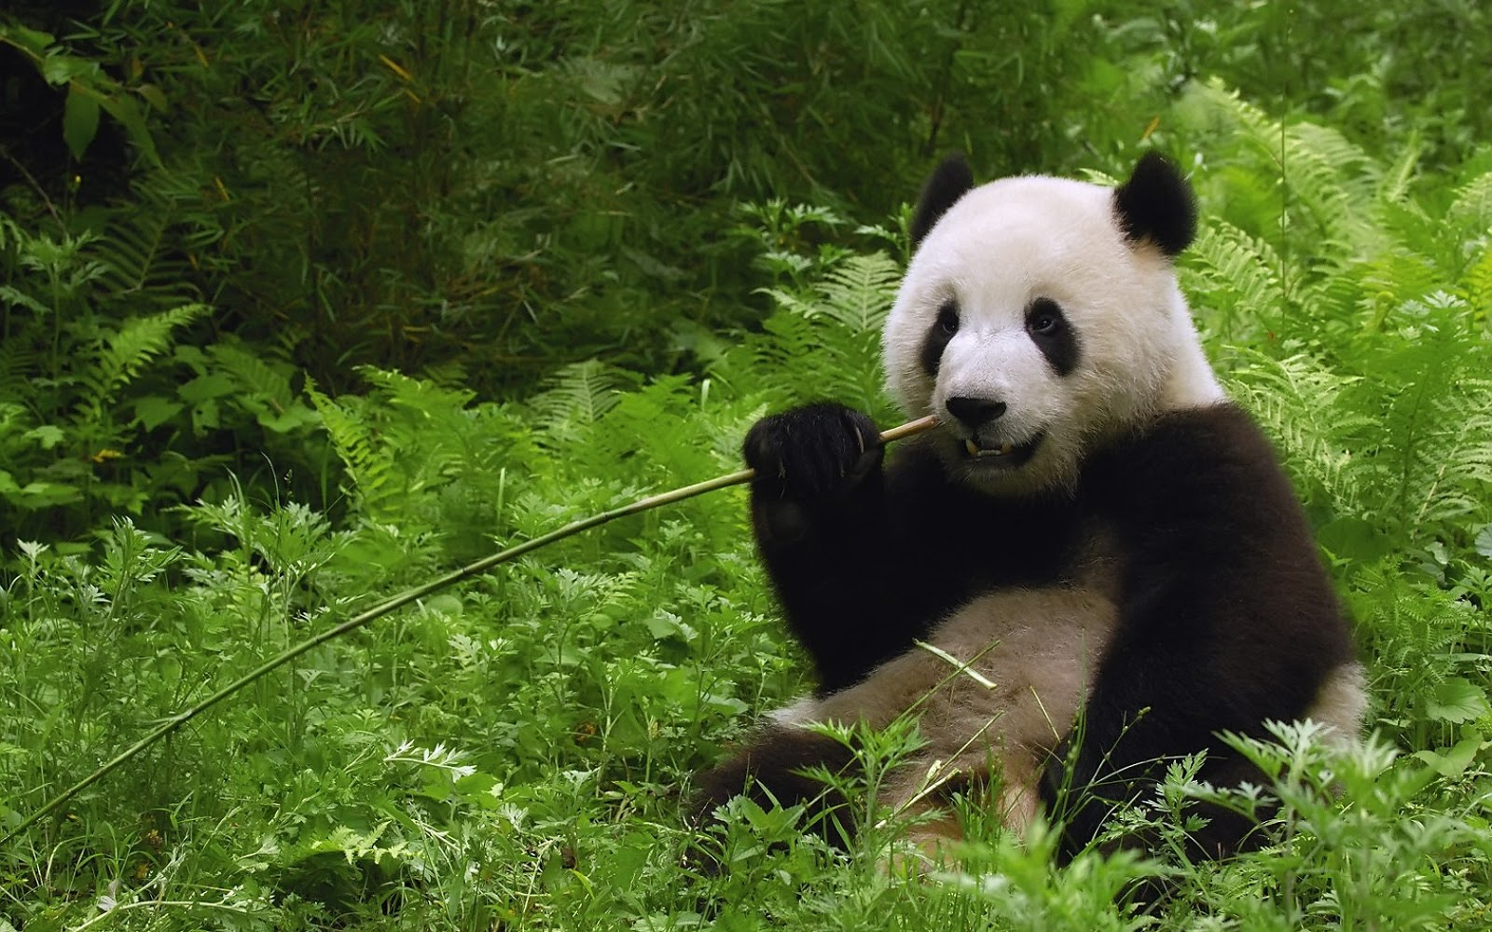
- 什么动物有圆圆的肚子?
shénme dòngwù yǒu yuányuánde dùzi
- 可爱的熊猫有圆圆的肚子
kěài de xióngmāo yǒu yuányuánde dùzi

Images from the following resources:

- http://www.prosportstickers.com/products/Bunny-Tail-Vinyl-Diecut-Decal.html#
- http://www.prosportstickers.com/products/Bunny-Tail-Vinyl-Diecut-Decal.html#
- http://dietfooddelivery.biz/yellow-baby-chickens/
- http://www.personal.psu.edu/afr3/blogs/SIOW/2011/10/the-elephants-trunk.html
- http://uploads.ronitbaras.com/2008/12/clip-image0028.jpg
- http://1.bp.blogspot.com/-ynzZIaueX5A/Ua8c_aaSvGI/AAAAAAAAHPU/WfrmQ0I3ULA/s1600/panda+bear+wallpaper+1.jpg

